UML Assignments
Komal Barnwal
- Design and draw UML class diagram to represent an airline reservation system. The system enables the customer to search for airline flight on a specified date and choose a flight based on some details like availability. The customer can reserve a flight or cancel his reservation. The system displays all the flight details such as flight number, name, price and duration of journey.
UML class diagram for Airline Reservation System:
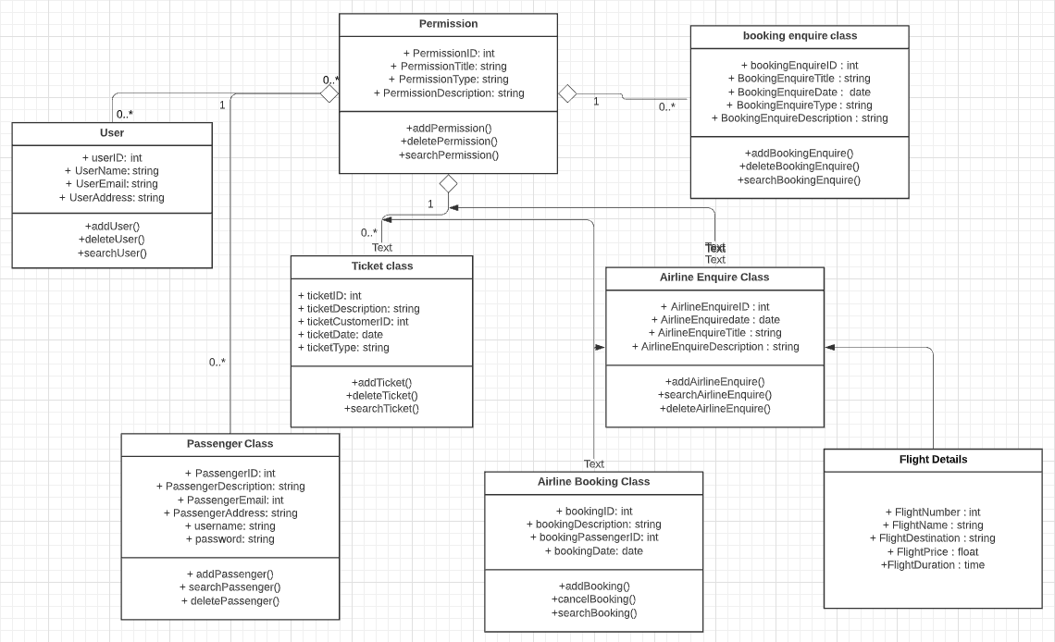
- Design and draw UML class diagram with attributes, behaviour, and class relationships for the following scenario. In a university there are various departments. A department has a name and is associated to classrooms and offices. An employee working at the university has a unique Id and can be a professor or an instructor. A professor can be a full professor or associate professor, or assistant professor and he/she belongs to a department in the university. Offices and classrooms also have unique IDs and classrooms have fixed number of seats. Also, every employee is assigned an office.
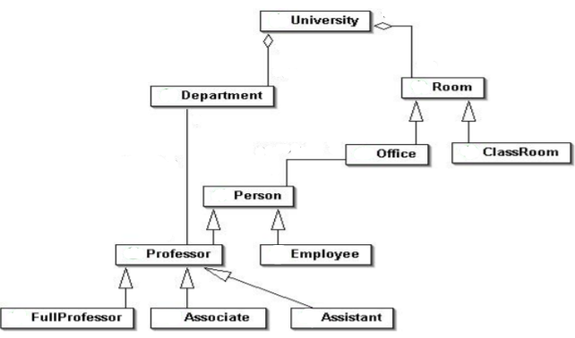
3. Draw an activity diagram for the given scenario where a student needs to enroll with the university for the given course.Process for student enrollment in the university is as follows:
• An applicant wants to enroll in the university.
• The applicant hands a filled-out copy of Enrolment Form.
• The registrar inspects the forms.
• The registrar determines that the forms have been filled out properly.
• The registrar informs student to attend in university overview presentation.
• The registrar helps the student to enrol in seminars
• The registrar asks the student to pay for the initial tuition.
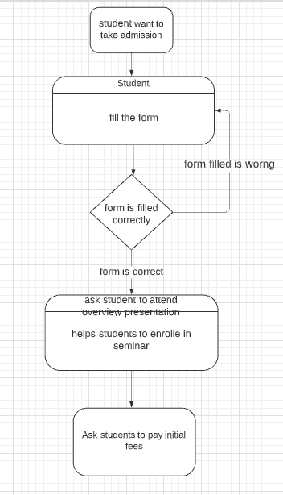
- A scenario of Online Library Management System is given below. You need to refer the use case diagram and moving further need to create a sequence diagram for the same.
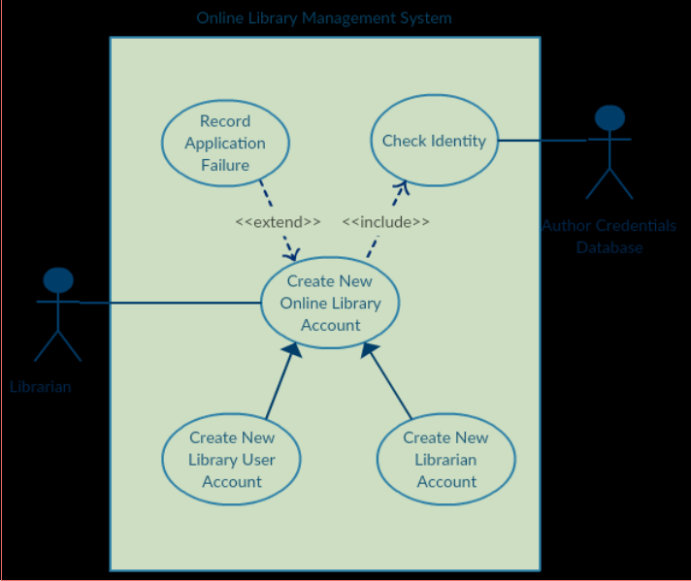
Here are the steps that occur in the given use case named ‘Create New Library User Account’.
• The librarian requests the system to create a new online library account
• The librarian then selects the library user account type
• The librarian enters the user’s details
• The user’s details are checked using the user Credentials Database
• The new library user account is created
• A summary of the new account’s details is then emailed to the user.
